ERD DIAGRAM-ANTONIO HALILI
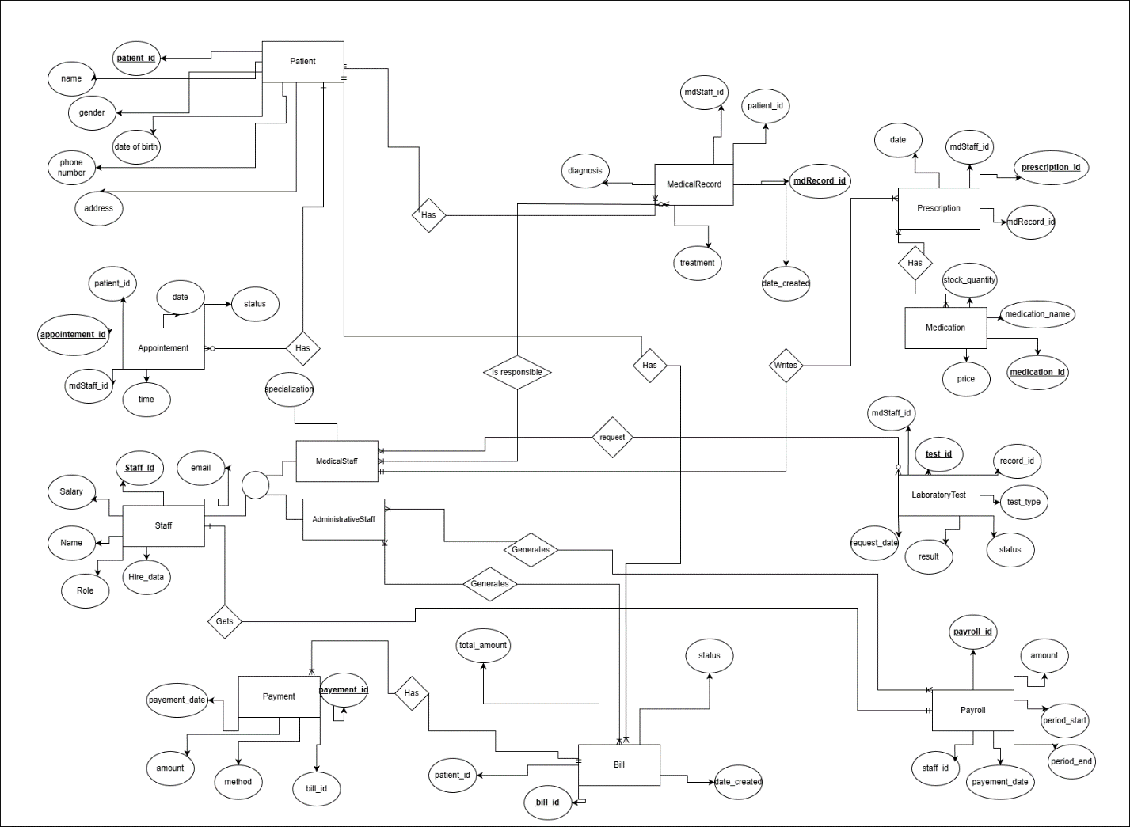

Administrator State Diagram-Antonio Halili
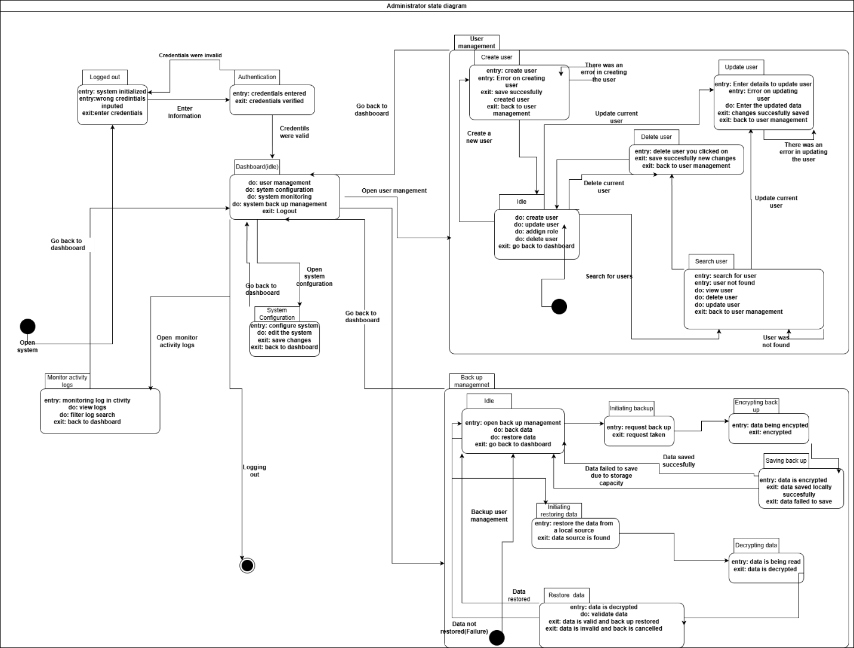

Laboratory State Diagram-Klajd Hotaj
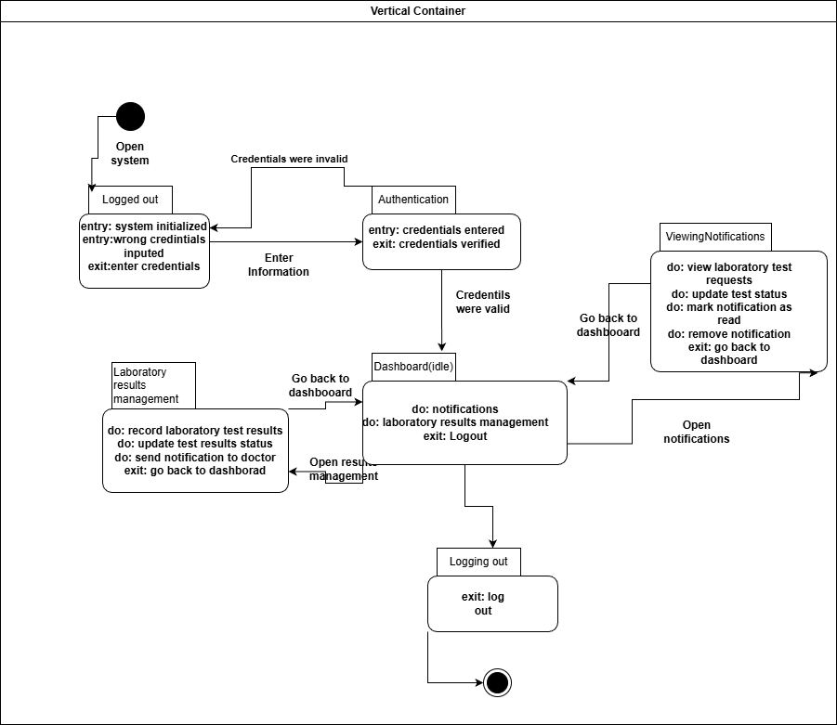

HR Officer State Diagram-Zejd Dervishi
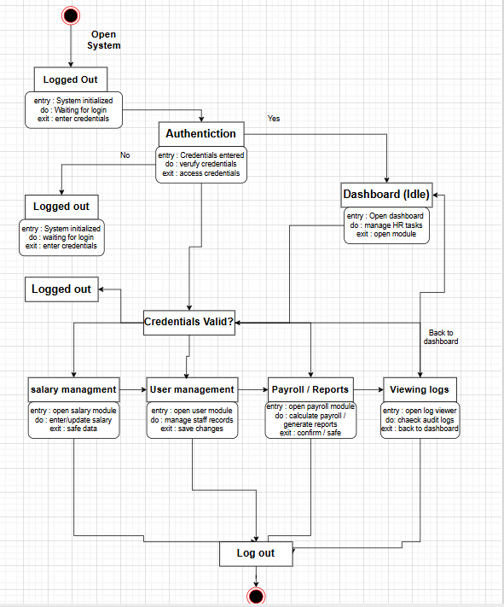
Patient State Diagram-Zejd Dervishi

